Retail Supply Chain Analytics Dashboard using Power BI
Prepared By: Anuradha Vijay Wavge
Tool Used: Power BI
Project Type: Data Analytics / Business Intelligence Project

Table of Contents
1. Overview: 1
2. Project Objectives: 1
3. Tools & Technologies Used: 1
4. Dataset Information: 2
4.1 Sales Data Table: 2
4.2 Product Master Table: 2
4.3 Inventory Data Table: 2
4.4 Supplier Data Table: 3
4.5 Store Data Table: 3
5. Data Modeling & Relationships: 3
6. Dashboard Details: 4
6.1 Executive Overview Dashboard 4
6.2 Sales & Product Analysis Dashboard 5
6.3 Inventory & Supply Chain Dashboard 5
7. KPIs Used: 6
8. Key Insights: 6
9. Challenges Faced: 6
10. Conclusion: 7
11. Future Enhancements: 7

1. Overview:
This project focuses on analyzing retail sales, inventory management, and supply chain operations using Power BI. Interactive dashboards were developed to monitor business KPIs, analyze sales trends, track inventory performance, and identify supply chain risks. The project helps businesses make data-driven decisions through visual analytics and reporting.

2. Project Objectives:
• Analyze sales performance across different regions and categories
• Monitor inventory availability and stock levels
• Track supplier and shipment performance
• Build interactive dashboards for business insights
• Identify low stock products and delayed shipments
• Improve business decision-making using data visualization

3. Tools & Technologies Used:
Tool | Purpose
Power BI | Dashboard Development
DAX | KPI Calculations
Power Query | Data Cleaning
Excel | Data Source
Data Modeling | Relationship Management

4. Dataset Information:
The dataset used in this project contains information related to retail sales, products, suppliers, inventory, shipments, and store regions. Multiple tables were connected using relationships to create an interactive analytical data model.
- Sales Data
- Product Master
- Inventory Data
- Supplier Data
- Store Data

4.1 Sales Data Table:
The Sales Data table contains transactional sales information including order details, product sales, revenue, quantity sold, and customer-related metrics. This table is primarily used for analyzing sales performance, revenue trends, and regional business growth.
Important Columns:
Order ID | Product ID | Sales Amount | Quantity | Profit |Region

4.2 Product Master Table:
The Product Master table contains product-related information such as product names, categories, sub-categories, and product identifiers. This table is used to categorize and analyze products across different dashboards.
Important Columns:
Product ID | Product Name | Category | Sub-category

4.3 Inventory Data Table:
The Inventory Data table stores inventory-related information including stock quantity, stock status, inventory levels, and warehouse data. This table helps monitor inventory availability and identify low stock products.
Important Columns:
Product ID | Stock Quantity | Inventory Status | Warehouse | Reorder Level

4.4 Supplier Data Table:
The Supplier Data table contains supplier information such as supplier names, delivery performance, shipment details, and supplier activity metrics. It is used for supply chain performance analysis.
Important Columns:
Supplier ID | Supplier Name | Shipment Status | Delivery Time

4.5 Store Data Table:
The Store Data table contains store and regional information used for geographic sales and inventory analysis. It supports region-based filtering and performance tracking.
Important Columns:
Store ID | Region | City | Store Type

5. Data Modeling & Relationships:
Relationships were created between multiple tables using common keys such as Product ID, Store ID, and Supplier ID. A structured data model was developed to enable interactive filtering, slicers, and dashboard analytics across different business domains.

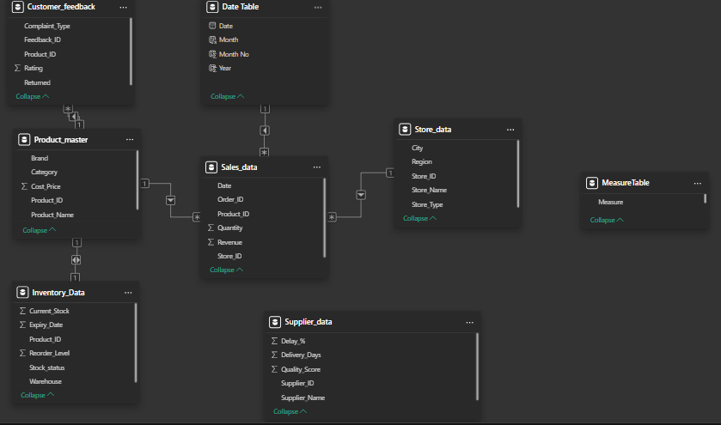Figure: Data Model and Table Relationships

6. Dashboard Details:

6.1 Executive Overview Dashboard

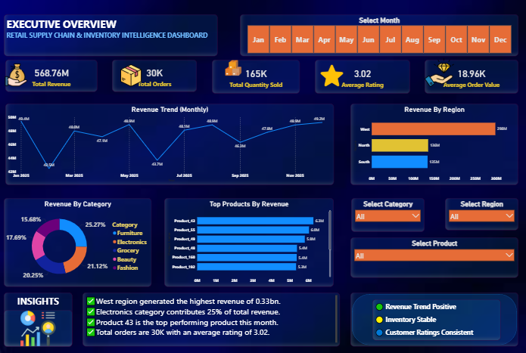
Figure 1: Executive Overview Dashboard

The Executive Dashboard provides a high-level overview of overall business performance. It includes KPIs such as total revenue, profit, orders, and inventory metrics. This dashboard helps management quickly monitor business operations and performance trends.

6.2 Sales & Product Analysis Dashboard

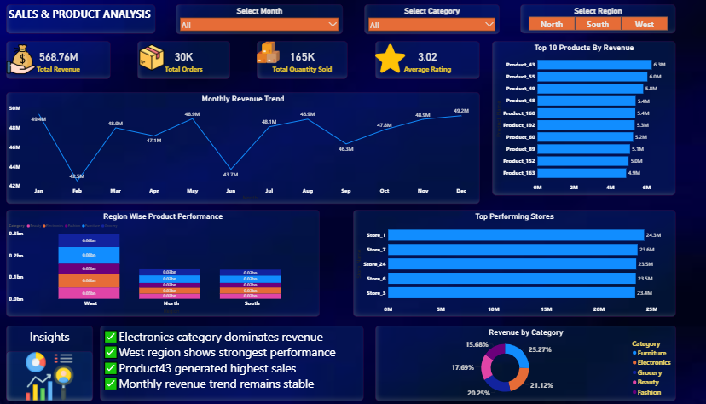
Figure 2: Sales and Product Analysis Dashboard

This dashboard analyzes sales trends, top-performing products, regional sales distribution, and category-wise performance. Interactive visuals and slicers allow users to explore sales insights efficiently.

6.3 Inventory & Supply Chain Dashboard

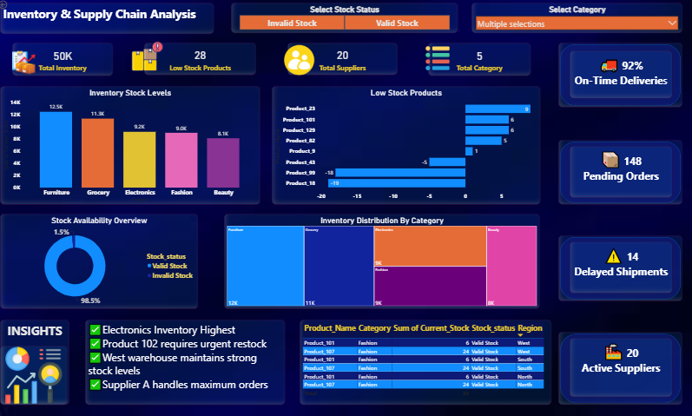
Figure 3: Inventory and Supply Chain Dashboard

This dashboard focuses on inventory monitoring, supplier analysis, stock availability, delayed shipments, and low stock products. It helps identify supply chain risks and inventory management issues.

7. KPIs Used:
• Total Revenue
• Total Profit
• Total Orders
• Inventory Value
• Low Stock Products
• Active Suppliers
• Delayed Shipments
• On-Time Deliveries
• Average Inventory Level

8. Key Insights:
• Electronics category contributed significantly to inventory distribution
• Some products showed critically low stock levels
• Delayed shipments impacted supply chain performance
• Regional sales performance varied across different store locations
• Inventory tracking helped identify stock management risks

9. Challenges Faced:
• Managing relationships between multiple tables
• Handling slicer interactions across dashboards
• Designing responsive and visually balanced dashboards
• Maintaining consistency in themes, charts, and KPIs
• Organizing business data for meaningful analysis

10. Conclusion:
This project enhanced understanding of Power BI dashboard development, data modeling, KPI analysis, and business intelligence reporting. The dashboards successfully transformed raw retail and supply chain data into interactive analytical insights to support business decision-making and operational monitoring.

11. Future Enhancements:
• Add advanced DAX calculations
• Implement drillthrough and tooltip pages
• Add forecasting and trend analysis
• Develop mobile-friendly dashboard layouts
• Enhance interactivity with advanced Power BI features

